Alternative (3 mins)

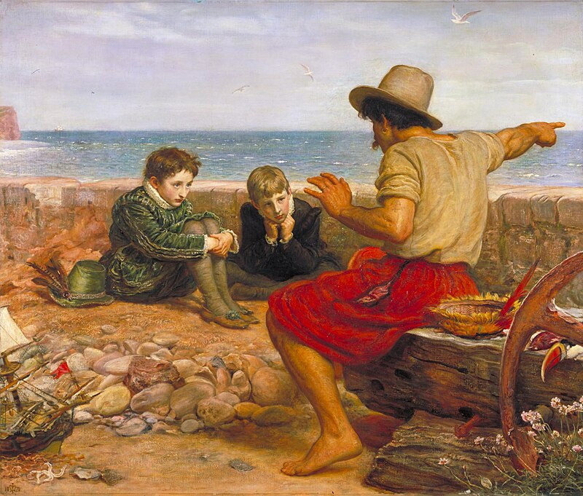

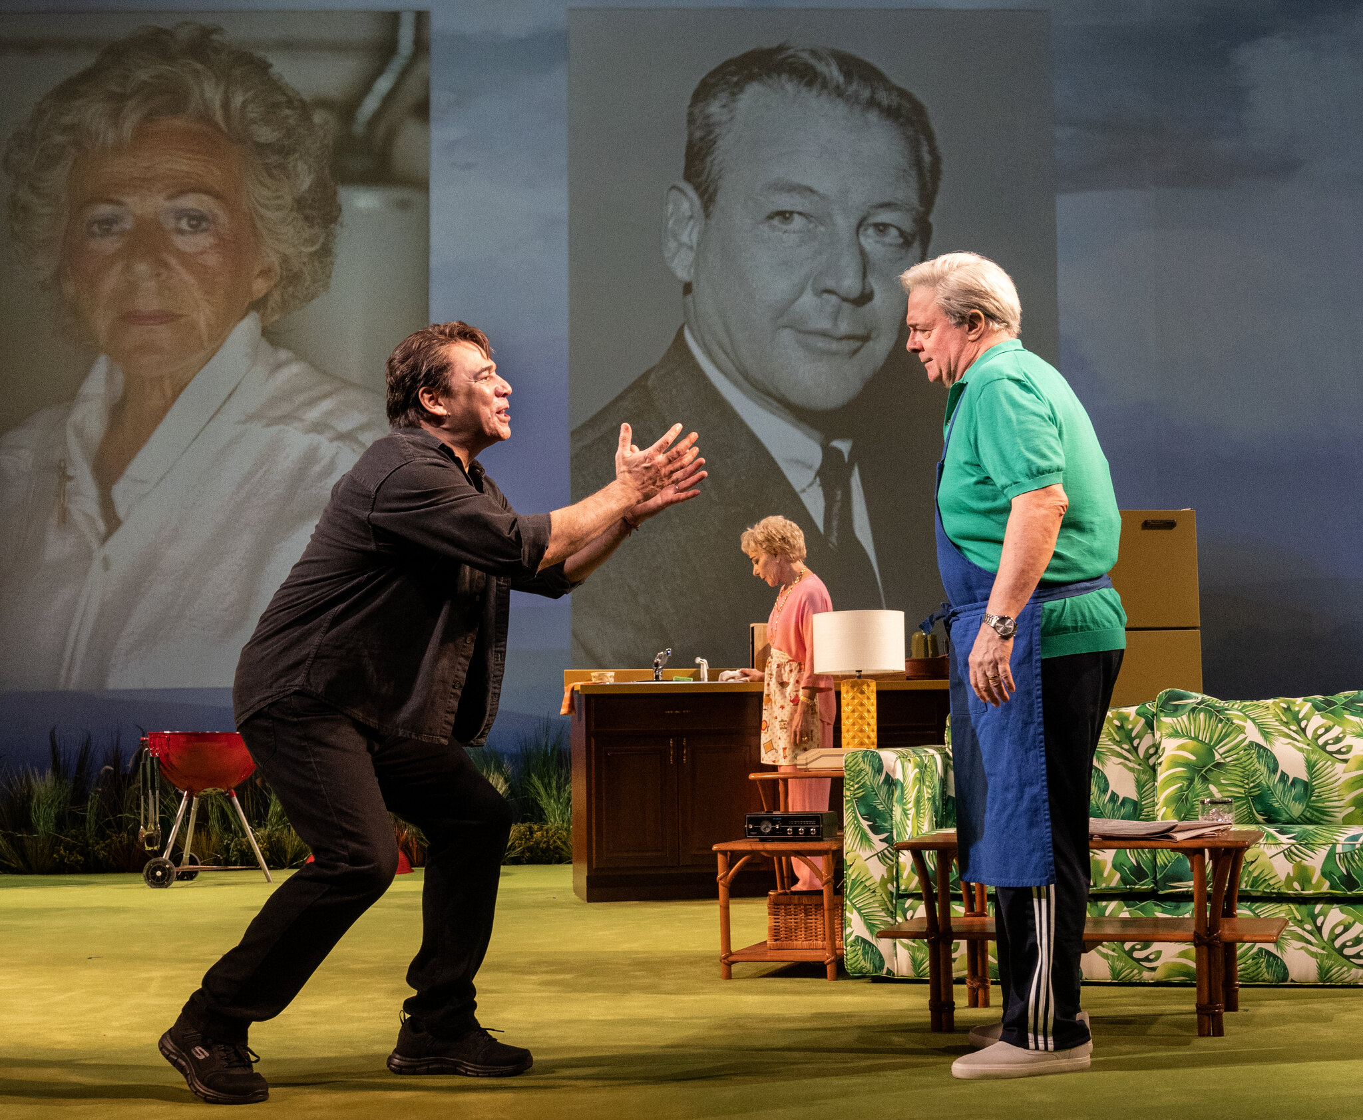

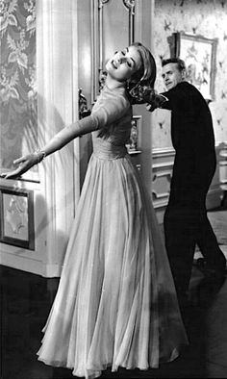

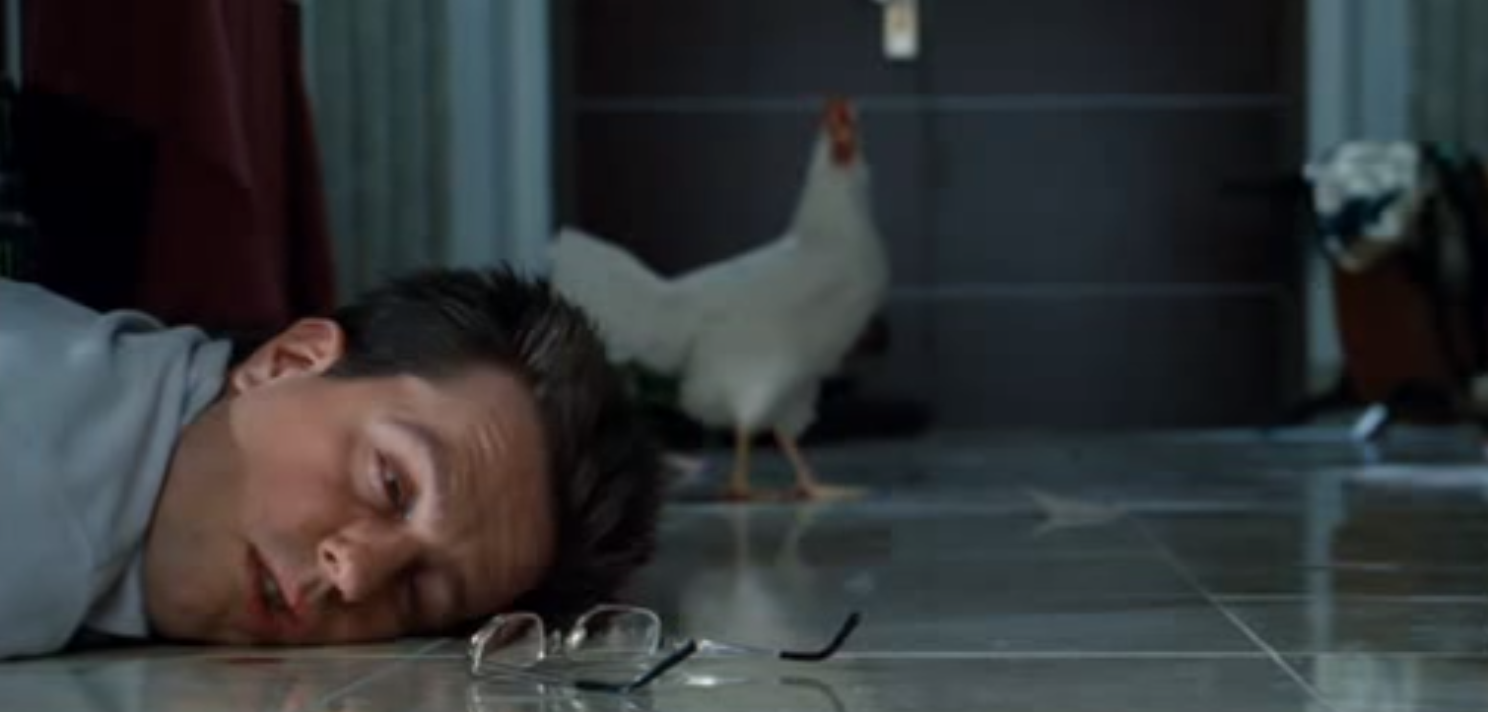

Why (2 mins)

Why is the blackboard black?

Why do we never have absolute equality?

Why do people procrastinate?

Why do we lie?

Reversal (1 min)

Doctor treating a patient.

Chef cooking food in a restaurant.

Police officer enforcing the law.

Author writing a book.

Analogy (3 min)

Shortsighted person finding their way around

Traveler in strange country trying to find the train station

Looking for keys lost in the house

Doing a crossword puzzle

Hint: Three key parts of analogy includes
- Break into steps
- Abstract
- Apply Analogy

Random generator (final challenge, 3 mins)

Use the random word generator to come up with two words. Connect them together in a story then somehow link it to our class. One reroll allow.

