New York University Abu Dhabi



**FINAL PAPER**

CREATING: A CLASS ABOUT CREATING?

DARKO SKULIKJ

Creating, June 2024

Soo..This is the end? It’s already done? I swear I feel like we just came to Berlin yesterday. This class was SPECIAL. Let’s start off from the beginning.

I’m going to be honest, this was my last class in my class selection for J-term, yes, 6th choice, but it turned out to be a trip I will remember (a lot of doner, sightseeing, basketball and gym), oh yeah and if professor you are reading this, a lot of nice classes and artist visits too 🙂

**Part 1: Some nice chicken, climbing roofs and enjoying some pizza with new friends!**

As expected from me, the first thing I did when I came here was cook some chicken and pasta. I don’t know why I’m mentioning that but it just seems like a funny analogy for the amount of food I’ve been eating here. Picture for reference:

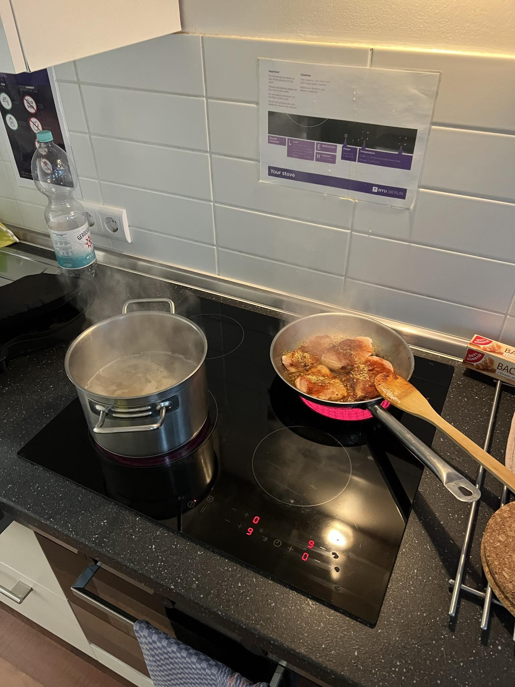

First day of classes was incredible. We got to learn about what the class is all about and I was very excited for what was about to come, oh yeah and after class I also climbed the roof of a building and went to a nice neapolitan pizza restaurant with my new friend (now little sister) Mariam. Enjoy some of the photos: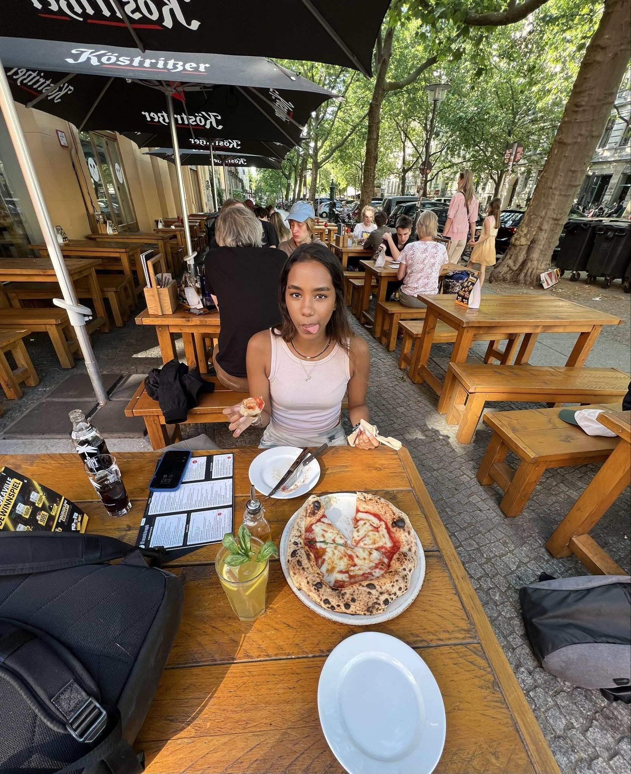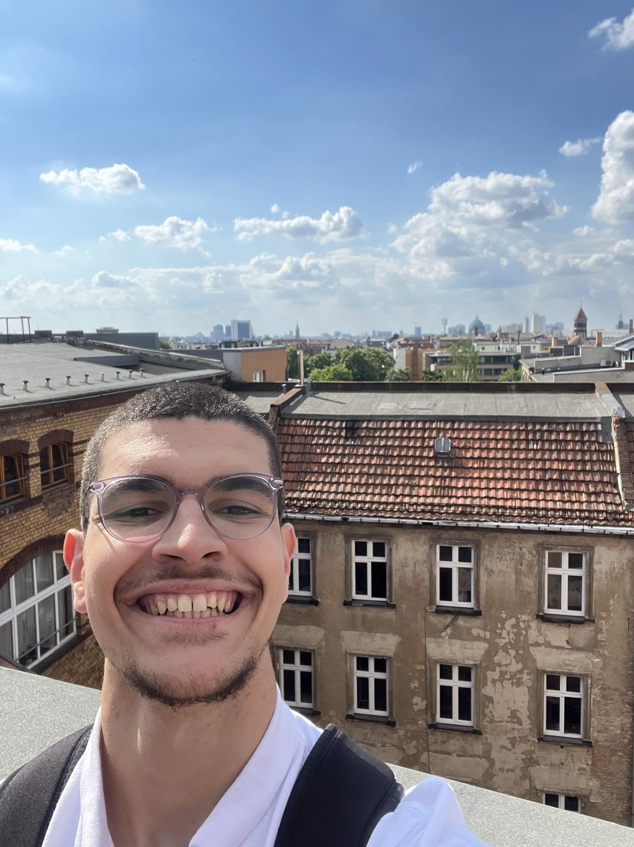

**Part 2: We need to focus on the class!**

Overall I didn’t have any expectations for the class but it actually turned out to be so thought provoking and actually made me change the ways I think about the whole creative process. We got introduced to topics like lateral thinking, flow state and we also got introduced to some creative thinking methods which proved to be very useful (analogy, the “why” method, reversal).

A huge plus for the class were all the studio visits that we had. Even though I did not really have a particular liking of some of the works - mostly the experimental artists since I wouldn’t listen to their music while cooking haha, I was actually blown away and very happy to learn what is happening in their head when they are creating their pieces. I learned how to cherish the process and pursue projects where I put myself and my experiences first and try to make something out of it. Favorite artists: Otis Sandsjo (definitely a person who is so passionate about the work that he makes), the field.ai studio (big team, big works), and the recent visit of Marco’s lab (that guy is so knowledgeable, calm and smart).

Apart from the studio visits, I feel like I definitely challenged myself with the production works, where I mostly created soundscapes since I haven’t done that before and wanted to try something new. I would not say they were listen-to-while-cooking worthy but still I am very proud of each and every work I have created.

**Part 3: A lot of Basketball and a lot of Berlin!**

I learned that Berlin is an amazing city. I was mostly playing basketball 3-4 times a week and got to meet some amazing people. Check out these photos:

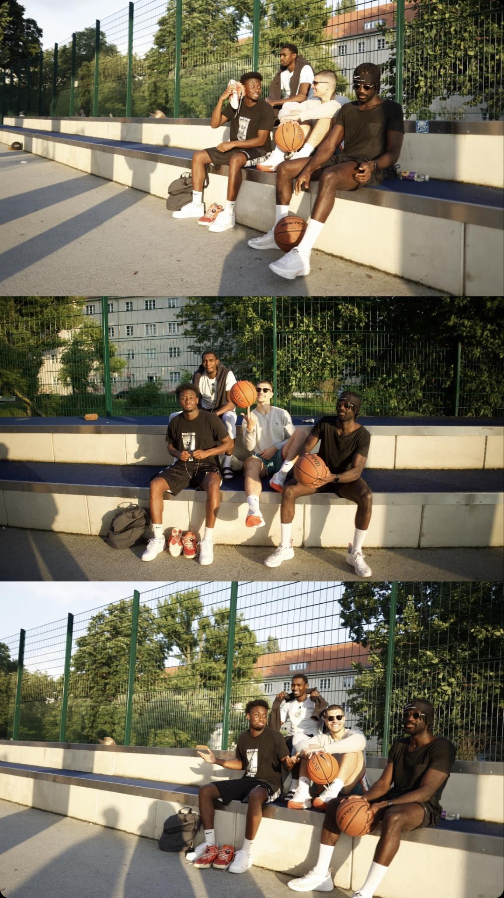

Berlin is also a city with a lot of soul, and we went to a lot of parties, all of them very cool! At the same time, I loved visiting the little toys and games shops, it really awakened the little kid in me, check out this one: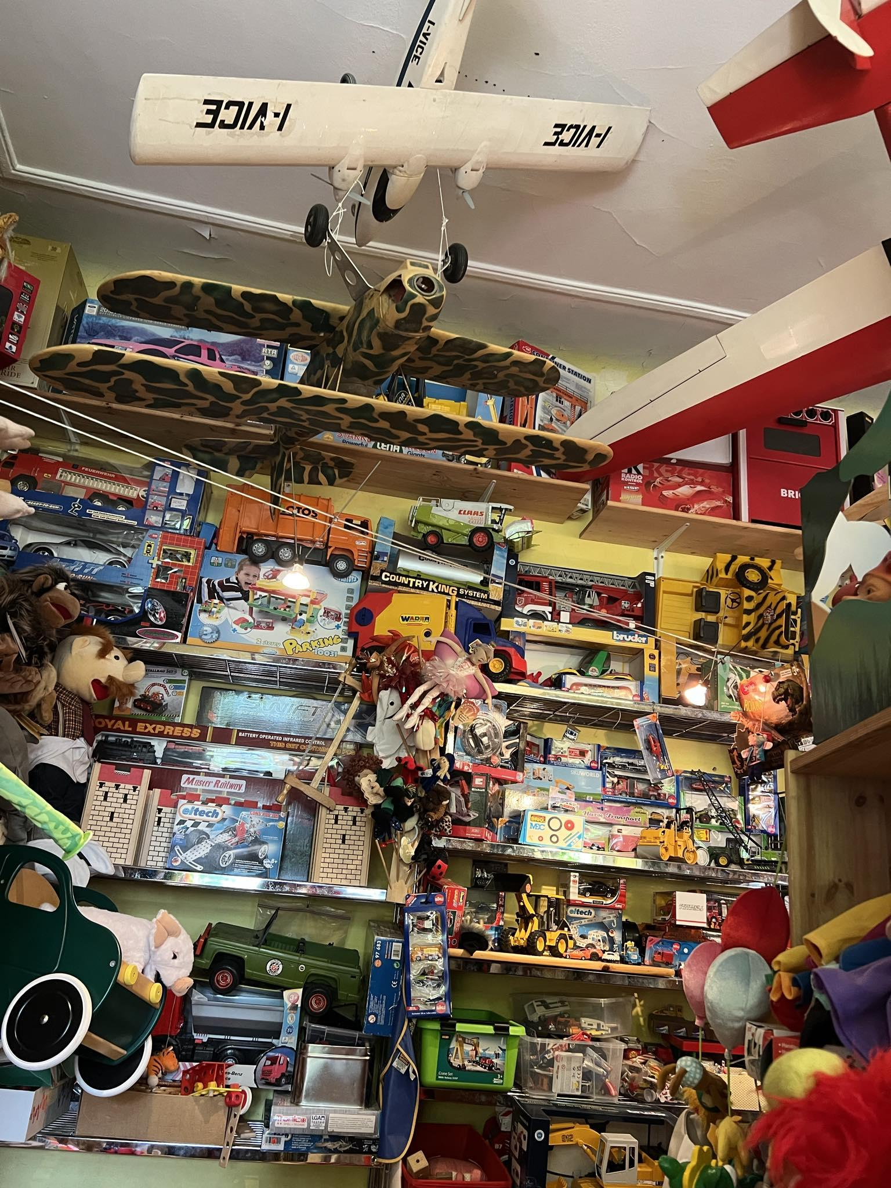

At the end of the day, some relaxation was also needed so if you need a recommendation for a show, definitely take a look at here:

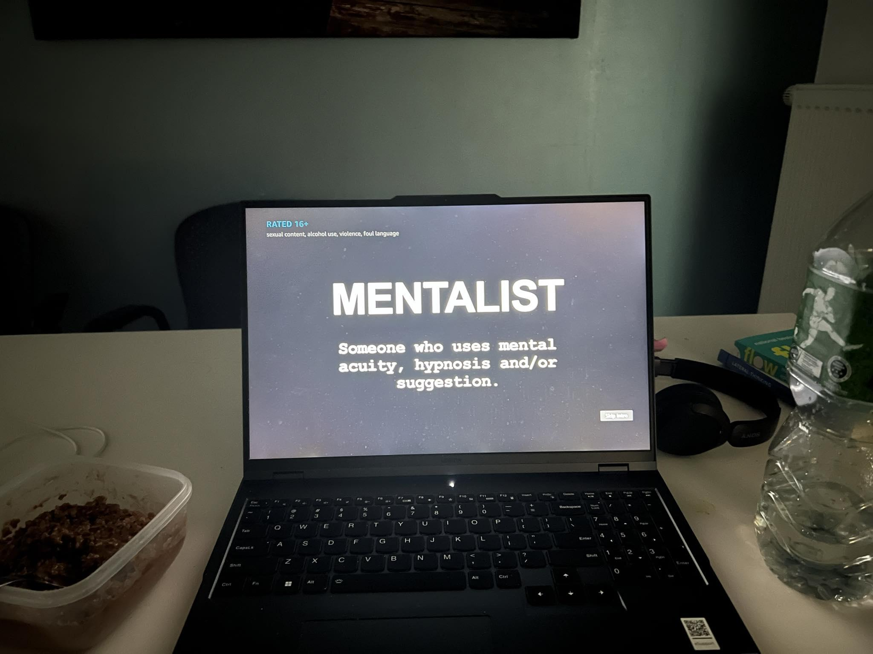

Overall, this was an amazing experience and I would definitely recommend for everyone to not only visit Berlin but also take part in this class, it will really change your views on how the whole creative process works.

Special Thanks to Professor Aaron Sherwood!

Stay Safe!